VISVESVARAYA TECHNOLOGICAL UNIVERSITY

“Jnana Sangama”, Belgaum 590014



*A Synopsis On*

**“COGNITIVE APPREHENSIVE DEVICE”**

*Submitted in partial fulfillment of the requirements for the award of the degree of*

Bachelor of Engineering

In

Computer Science and Engineering

*By*

|  |  |
| --- | --- |
| **Prerna Bajaj** | **Raksha Desai** |
| **1BM12CS0082** | **1BM12CS088** |
| **Pronoy Dalal** | **Vardaan Tyagi** |
| **1BM12CS079** | **1BM12CS138** |

*Under the guidance of*

**Mr. LOHITH JJ**

Assistant Professor, Department of CSE,

BMSCE

*Project carried out at*

BMS College of Engineering, Bangalore



DEPARTMENT OF COMPUTER SCIENCE AND ENGINEERING

BMS COLLEGE OF ENGINEERING (Autonomous College under VTU)

Bull Temple Road, Basavanagudi, Bangalore - 560019

**INRODUCTION**

Jewelry has been an integral and almost essential part of all cultures—prehistoric to contemporary period. Jewelry with special powers is also part of folklore and mythology. That the modern technology can indeed endow jewelry with special abilities is the premise for this project.  
Today with advances in affordable miniaturization technologies and societal acceptance of wearable technical gadgets, it is possible to make jewelry that can incorporate sensors, actuators, and wireless communication chips to enhance human experience in daily lives. This is known as Cognitive Jewelry.

While you probably feel safe at home with your security system, that feeling of protection may not extend far from your front door. This wearable device has a technology that can help offer you that sense of security no matter where you are. This device is being formulated for the society, especially for the safety of women, which is a major concern in today’s life. The device is used to provide flexibility and choices for the wearer

**OBJECTIVE**

* To design a robust wearable product that works through gesture recognition, which can be implemented in the field of security.

- To understand the basic working of ARM Cortex Mo+ microprocessor and explore it’s working with different gesture oriented devices

* To understand and explore the working of Accelerometer and implement gesture sensing.
* To understand the working to BLE (Bluetooth Low Energy) and integrate it with different devices to meet Product goals
* To help each other in the team and overcome all the difficulties faced during the generation of the product.

**REQUIREMENTS**

* HARDWARE REQUIREMENTS
* Atmel AT8052
* 3-Axis Accelerometer
* BLE(Bluetooth Low Energy)
* Handheld Device
* Batteries
* SOFTWARE REQUIREMENTS
* Keil C166 Development Tools
* 32 bit Operating System (Windows/MAC)
* Eclipse SDKs

**HIGH LEVEL DESIGN**

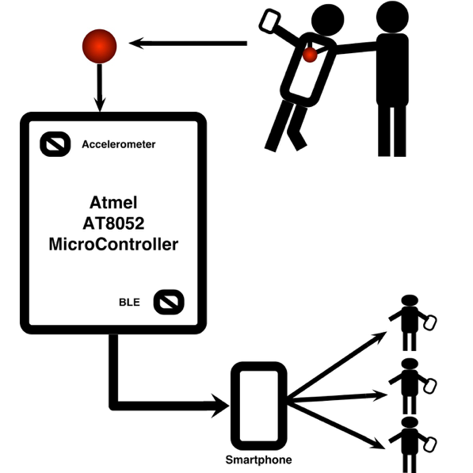

**FIGURE: HIGH LEVEL DESIGN**

**SEQUENCE DIAGRAM**

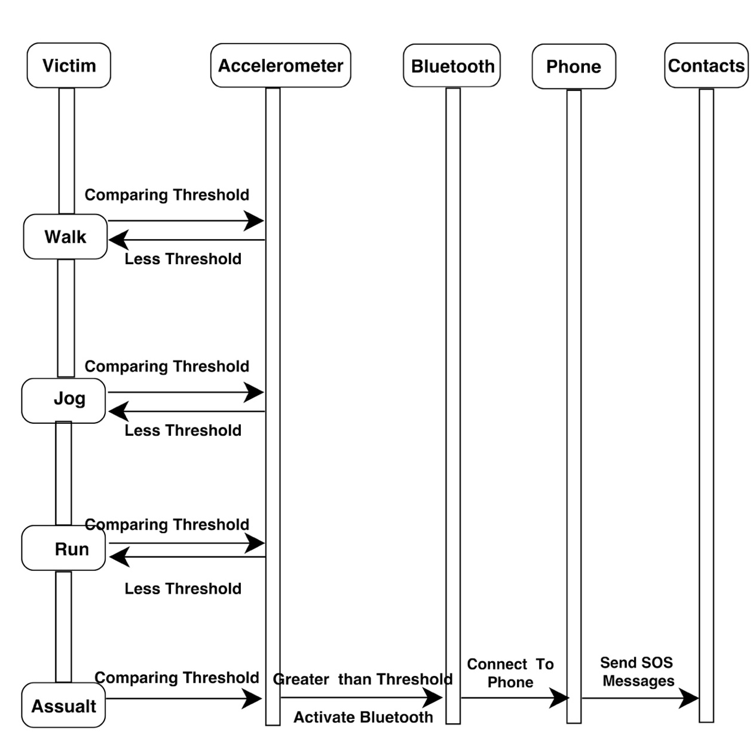

**FIGURE: SEQUENCE DESIGN**

**IMPLEMENTATION**

**Atmel AT8052 Microcontroller**

The 8052 board is a useful tool for embedded control and robotics projects for both students and hobbyists. Its versatile design and programmable microcontroller lets you access numerous peripheral devices and program the board for multiple uses. The board has many I/O connectors and supports a number of programming options including 8051 assembly and C. With this board you can develop and prototype with any of 8052 40 pin microcontrollers. Having I2C based ADC embedded this board becomes a perfect board for those who wants to interface various analog sensors. The RS232 driver on board allows easy connection with PC or other embedded hardware. The board has User buttons and status LEDs. The bridge rectifier allows this board to be powered with both AC and DC power supply adapters.

**3-Axis Accelerometer**

This sensor buffers a piezoelectric transducer. As the transducer is displaced from the mechanical neutral axis, bending creates strain within the piezoelectric element and generates voltages.

The 3-Axis Accelerometer consists of three –5 to +5 g accelerometers mounted in one small block. Using the appropriate data collection hardware and software, you can graph any of these components, or calculate the magnitude of the net acceleration. The 3-Axis Accelerometer can be used for a wide variety of experiments and demonstrations, both inside the lab and outside. The Accelerometer is a small, thin, low power, complete 3-axis accelerometer with signal conditioned voltage outputs. The product measures acceleration with a minimum full-scale range of ±3 g. It can measure the static acceleration of gravity in tilt-sensing applications, as well as dynamic acceleration resulting from motion, shock, or vibration. The user selects the bandwidth of the accelerometer using the CX, CY, and CZ capacitors at the XOUT, YOUT, and ZOUT pins. Bandwidths can be selected to suit the application, with a range of 0.5 Hz to 1600 Hz for the X and Y axes, and a range of 0.5 Hz to 550 Hz for the Z axis.

**Bluetooth Low Energy(BLE)**

Bluetooth low energy (Bluetooth LE, BLE, marketed as Bluetooth Smart) is a wireless personal area network technology designed and marketed by the Bluetooth Special Interest Group aimed at novel applications in the healthcare, fitness, beacons, security, and home entertainment industries. Compared to Classic Bluetooth, Bluetooth Smart is intended to provide considerably reduced power consumption and cost while maintaining a similar communication range. Bluetooth Smart was originally introduced under the name Wibree by Nokia in 2006. It was merged into the main Bluetooth standard in 2010 with the adoption of the Bluetooth Core Specification Version4.0. Bluetooth Smart is not backward compatible with the previous, often called Classic, Bluetooth protocol. The Bluetooth 4.0 specification permits devices to implement either or both of the LE and Classic systems. Bluetooth Smart uses the same 2.4 GHz radio frequencies as Classic Bluetooth, which allows dual mode devices to share a single radio antenna. LE does, however, use a simpler modulation system

**CONCLUSION**

* With the use of such wearable devices we can achieve more responsiveness which makes the user be completely independent on this device during an emergency and the person be less worried about the insecure environment.
* It's fashionable which makes it really very trendy and cool and can be worn with almost anything. Moreover, it is also portable and light in weight which makes it a very consumer friendly device.
* Finally, it can be really an inspiration for engineers to build such safety devices with better features in the future
* It is very important; one keeps in mind that the best protection you can give yourself is to avoid potentially dangerous situations as much as possible. After all, it is often said that prevention is better than cure. So try as much as possible to avoid being a victim of crime, and a great way to achieve this is to have a high level of technological security awareness or consciousness.

**FUTURE WORK**

* In future, a 6- axis accelerometer could be used to provide much precise and wider information in gesture recognition. It could be a lot more powerful when compared to the tri-axial accelerometers.
* A geo tagged data logging could be used in which the mapping of the location could be much precise and also sending in the data to the nearest police station or a friend could be implemented which can be achieved easily using the geo tagged data logging.
* Algorithm can be optimized to implement inverse surveillance.
* This wearable security device can be either implemented as an earring, or a hair clip or any such kind of an accessory which doesn't attract the attacker but at the same time do its job without any problem.

**REFERENCES**

[www.artemisfashion.com](http://www.artemisfashion.com)

[www.safelet.com](http://www.safelet.com)

[www.amulyte.com](http://www.amulyte.com)

[www.dhruvsuxsena.com/cognitive-jewellery/](http://www.dhruvsuxsena.com/cognitive-jewellery/)